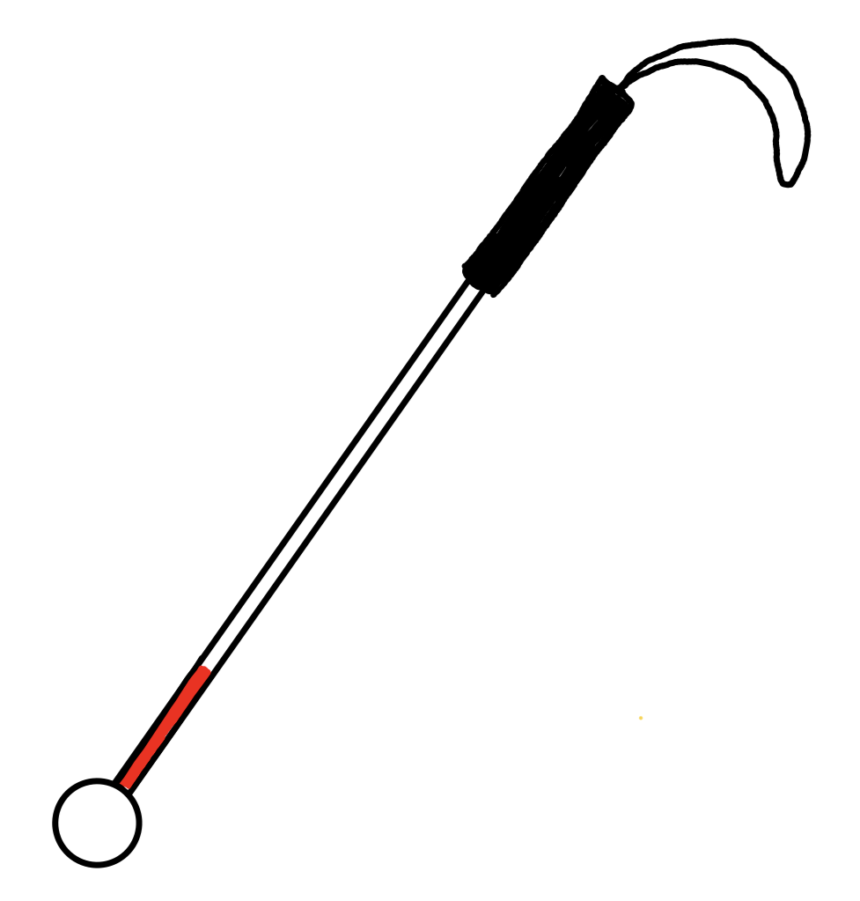
My White Cane
This is my cane and it’s my trusted friend.
From the strap on the top to the tip on the end.
I take it with me when I start my day.
I use it to find things that are in my way.

Tap! I found a pole and I go around,
Moving my cane smoothly to scan the ground.
Whoops! What’s that? I stop in my tracks.
Oh! I just found some really big cracks.
I can step carefully I don’t want to fall.
With my cane in hand, I’m walking tall.

Hey! Did I just find something new?
The cane tip went down, I think that’s a clue,
Oh, there’s a curb but no big deal,
I know it’s there, I know by feel.
So it’s a happy white cane day!
And we’ll have many more,
My white cane and I
are off to explore!

by Jessica McDowell

