Find all the basketballs 🏀 and mark your answer

🏀 🥎 🏀

🥎 🏀 🥏

There are 5 3 2 basketballs.

Find all the basketballs 🏀 and mark your answer

🍩 🏀 🍊 🏀

🏀 🍊 🏀 🍩

There are 5 3 4 basketballs.
You are a
🌟 Basketball STAR! 🌟
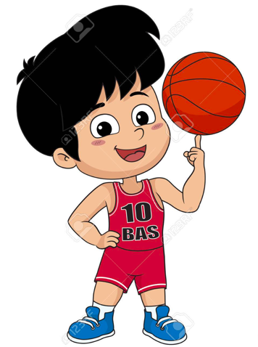
Find all the cookies 🍪 and mark your answer

🍪 🥐 🥞

🍊 🍪 🥔

There are 2 6 4 cookies.
Find all the cookies 🍪 and mark your answer

🍪 🥐 🍪 🥞

🍊 🍪 🥔 🍪

There are 2 6 4 cookies.
You are a
🍪 cookie monster! 🍪
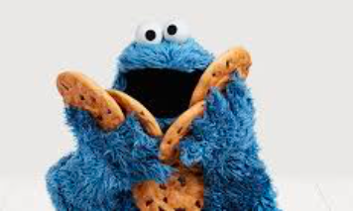
Find all the red cars 🚗 and mark your answer

🚗 🦀 🎒

🚗 🧰 🚗

There are 4 3 5 red cars.
Find all the red cars 🚗 and mark your answer

🚗 📕 🚗 🦀 🚗

🚗 🎒 🧰 🚗 🚒

There are 4 3 5 red cars.
You are
🚗 Number 1! 🚗
