Basic Sighted Guide Techniques
When guiding a student using Sighted Guide technique, you are responsible for their safety. Your body movement and language are critical elements for assisting this person. Remember to follow these basic techniques, which have been previously taught to the student, and be sure to communicate relevant information about the surroundings and situation.

- Make contact. Introduce yourself both verbally and by touching your hand to the student’s. Explain that you will be the student’s guide and he/she is to proceed with you. | 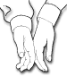
- Grip. The student will take hold of your arm just above your elbow. Their grip should be firm. If working with a younger student, offer your pinkie, hand or wrist as this height will be more appropriate for the student. | 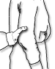
- Stance. Keep your arm relaxed. The student should stand beside you, about a half pace behind. REMEMBER: When guiding a student, you occupy a wider space than you are used to and it is YOUR responsibility to lead the student around any obstacles. | 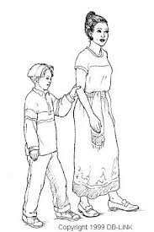
- Narrow Places/Doorways/Obstacles. For narrow aisles, doorways and other places where it is difficult to walk two abreast, make a definite move with your arm backwards and over to the centre of your back. The person being guided should respond by straightening out his/her arm and stepping directly behind you. His/her arm must remain extended to prevent either of you from tripping over the other’s feet. When you have passed through the narrow place or around the obstacle, return your arm to its normal position and the student should return to his/her previous position by your side. | 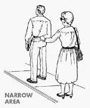
- Stairs/Curb. Tell the student you are approaching stairs and whether they are going up or down. Always approach stairs and curbs at right angles and STOP as you reach them. If the student is not on the handrail side, ask him/her to change sides in order to reach the handrail. As you step up/down, you will remain one step ahead and proceed in rhythm. STOP when you reach the top/bottom of the stairs (remember he/she is one step behind you) and verbally indicate the end of the stairs before proceeding. | 