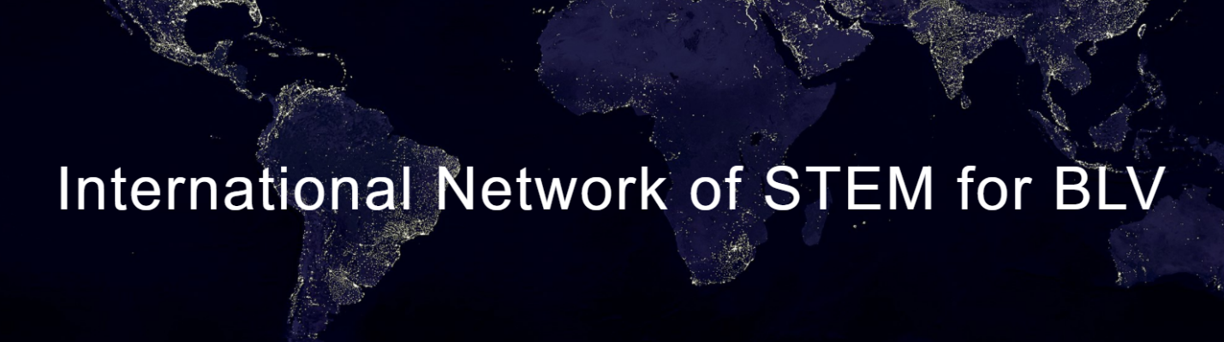
Founder’s Word
HELLO to all of you who care about STEM (science, technology, engineering, and mathematics) education and careers for those who are blind or have low vision (BLV)! Dr. M. Şahin Bülbül and I started this network with the aim of connecting people in different countries to facilitate the growth of the field. Eight countries (Canada, Germany, India, Japan, Mexico, Taiwan, Turkey, and United States) have joined this network. Currently, we are trying to get this network registered as a nonprofit organization so that we can accept donations and write grants for funding to get the work moving forward in the future.
Our website has a good initial structure now! Our next step is to gather resource information directly related to STEM for BLV from the eight countries and share those resources on the website. Many thanks to all the network's country representatives who will be contributing to this task! As an international community, we will share our resource information in English and other languages on our resource webpages.
Our vision is to create a world where the blind and low-vision have full access to STEM education and careers.
To achieve this vision, it will require consistent work that needs to be done in the field. Our two preliminary missions are as follows:
1. Building a global community through sharing resources: Compared to many other fields, STEM for BLV is a small one. So often, resources directly related to STEM for BLV are in different places, and thus, they are not easy to be found. One of our missions is to gather and provide resource information from different countries on this website for interested parties to access more easily.
2. Advancing the field of STEM for BLV through exchanging ideas: As a growing field, it is crucial to know what has been done and what others are thinking and doing in the field. Our forum, which is visible to the public and accessible to all users, serves this purpose for interested parties to exchange ideas that are directly related to STEM for BLV. Please continue to the next page.
We invite you to join the network as a member, a volunteer, and/or a country representative no matter you are a student, parent, educator, or researcher!
You can find more details about how to become a volunteer or a country representative on our Join Us webpage. If you simply want to join as a member, please fill out and submit the membership form. (No membership fees!) Once you have joined as a member, you will receive an email that notifies you of being added to our Google group named Intl STEM BLV Members. Then you will be able to receive the network’s updates, including our bi-monthly newsletters, as well as interact with other members by starting a conversation in the group to share information, seek advice, or exchange ideas at your own wish.
Additionally, be sure to check out and join our forum to keep yourself posted on a variety of information related to STEM for BLV from different countries! Below are four links for you to learn more about the network and to join us!

- Check out the website: https://www.intlstemblv.net/
- Join the forum: https://www.facebook.com/groups/4458585407596556
- Join as a member: https://tinyurl.com/y7scs7fn
- Become a country representative or volunteer: https://www.intlstemblv.net/join-us

Please forward this newsletter to those who you think might be interested! If you have any information related to STEM for BLV, such as resources or opportunities, that you would like to share with our members from all over the world, please email the information to us at intlstemblv@gmail.com.
I look forward to seeing us unite together to do something meaningful in the field!
Sincerely,
Founder of the International Network of STEM for BLV

