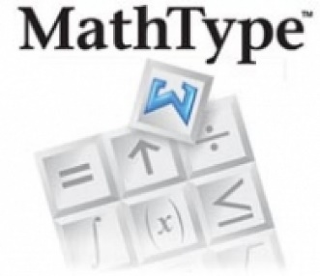
Producing Nemeth Code through

MathType, Word, and Duxbury

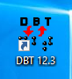
Who is this for?
Anybody who produces materials for students in Nemeth code.
Ideally, the solution outlined will help teachers more quickly produce materials containing Nemeth code for their students, including worksheets, study materials, and evaluations, that the students can access independently.

The basic steps
- Set up a Word doc with a UEB- and Nemeth-friendly template (MUST have Swift installed – free from Duxbury)
- MathType is used within Word to input different math equations and symbols to the document
- The document is opened in Duxbury and translated
(All programs described above were the most up-to-date versions when this guide was developed)

Preparing your document
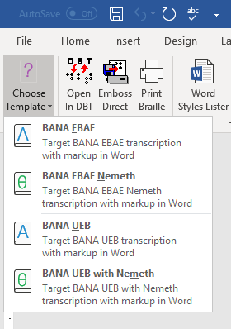
- Open and Save a Word document. Make sure it is NOT saved in a OneDrive folder (or other cloud storage folder, i.e. Google Drive or DropBox.
- Go to the Braille tab
- Select the “BANA UEB with Nemeth template” in the “Document” section of the ribbon

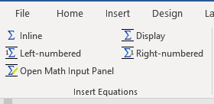
Add your content
- Type all print as you would normally
- For math content:
  - Go to the MathType tab
  - Select the “Inline” option in the “Insert Equations” section of the ribbon. A Mathtype window will open up.
  - In the MathType window, use the various buttons to create the equations you want. Do not create multiple equations at once.
  - When you are done with an equation, click on the X in the top right corner to close the window. Your equation should appear in your document, in line with the cursor position.

Send to Duxbury for Translation
- Go to the Braille tab and select the “Open in DBT” option in the “Output” section of the ribbon.
- The document’s contents should appear in print, with the mathematics appearing in print as well.
The mathematic notation should roughly be decipherable as matching the original content.
- Use the Control + T command, or click File => Translate to transcribe the document into braille
- The document should now appear in braille, with both print and math translated as UEB and Nemeth code.

