Creating Accessible Google Forms
Diane Brauner
Accessible Materials Workshop
Creating Digital Worksheets and Quizzes: Google Forms post on Paths to Technology

Google Forms Directions – Computer

Create a New Google Form
- Open your Google Drive.
- Select New Tab (rectangle beside My Drive – Google Drive tab).
- Select Apps (located below search text field in left corner).
- Select Google Forms (purple icon).
- Select Blank template (* See Change Format directions if desired).

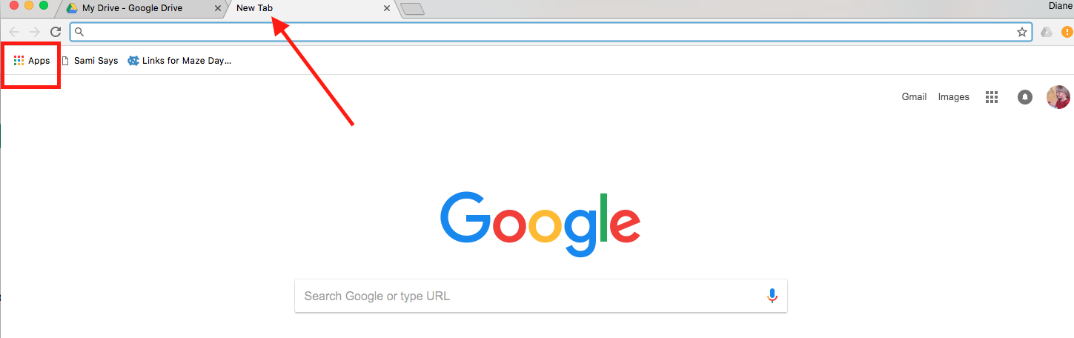

Creating Questions

First question is typically “Name”.
- Select the dropdown menu to the right of Multiple Choice > Select Short Answer.
- In the Question Text field, type “Name”.
- To add the next question, select the Add icon.
- Choose the type of question. Options are: Short Answer, Paragraph, Multiple Choice, Checkboxes, dropdown, linear scale, multiple choice grid, date, time.
- Type in the first question.
- If creating multiple choice answers, type in each answer option.

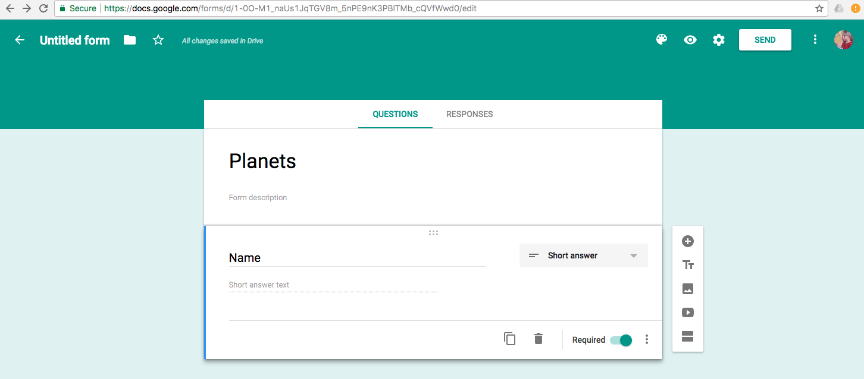

Types of Questions
You can create questions with these formats:
- Short answer
- Paragraph
- Multiple choice
- Dropdown menu options.
- Linear scale – rating scale 1 to 5
- Multiple choice grid
- Checkbox grid
- Date
- Time

Preview the Form
- To Preview the form: select Preview tab at the top of the page (looks like an eye).
- To exit Preview: select the “x” (at the top of the page) to close the preview tab.
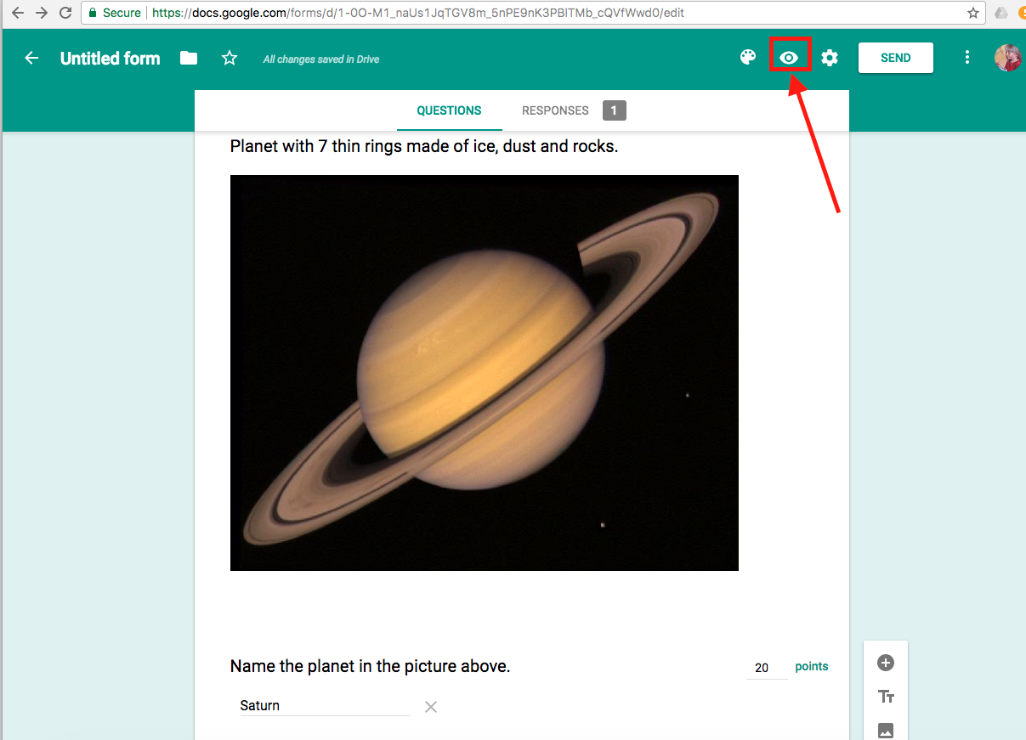

Accessibility - minimize visual clutter
If your student does best with one question per page (to minimize visual clutter), select the “Add Section” icon (last icon underneath the Add icon). You can give the new section the same title or add a new title, if appropriate.

Add Images
- Select the image icon.
- Add your desired image by:
- Dragging image to middle of the screen
- Choose an Image to upload (from your computer)
- Upload an image
- Take a snapshot
- By URL
- Your Albums
- Google Drive
- Search
- If desired, resize by dragging handle bars.
- Currently, there is not an option for adding an alt tag description; however, you can type the alt tag description in the Image Title text box.
- Add associated questions below the image. Note: If using images and videos, do not select ‘shuffling question order’ as the image/video is not associated with a specific question and they will not appear together.

Add Video
- Select the video icon.
- Paste URL or search YouTube videos.
- Resize video if desired by dragging handle bars.
- Add Title. Note: Videos should be audio described or created with quality descriptions of what is happening on the screen!
- Add associated questions below the video. Note: If using images and videos, do not select ‘shuffling question order’ as the image/video is not associated with a specific question and they will not appear together.

Change Order of Questions
- You can move the questions around by dragging them.

Required Answers
- Select “Required” for each question students must answer – do this AFTER you have completed and reviewed the entire form!

Create Answer Key
- When you have finished adding content, select Settings at the top of the page.
- Select the Quizzes button.
- Activate Make this a Quiz toggle button.
  - Choose between “Immediately after each submission” or “Later, after manual review”.
  - Choose what respondent can see: “missed questions”, “correct answers”, or “point values”.
  - Select Save button in the top right corner.
  - Select the correct answers in the quiz.
  - Select Answer Key.
  - Add number of points for that question (points is located in the top right corner of the question box – ONLY available after selecting Answer Key!
Note: Paragraph answers must be hand-graded.

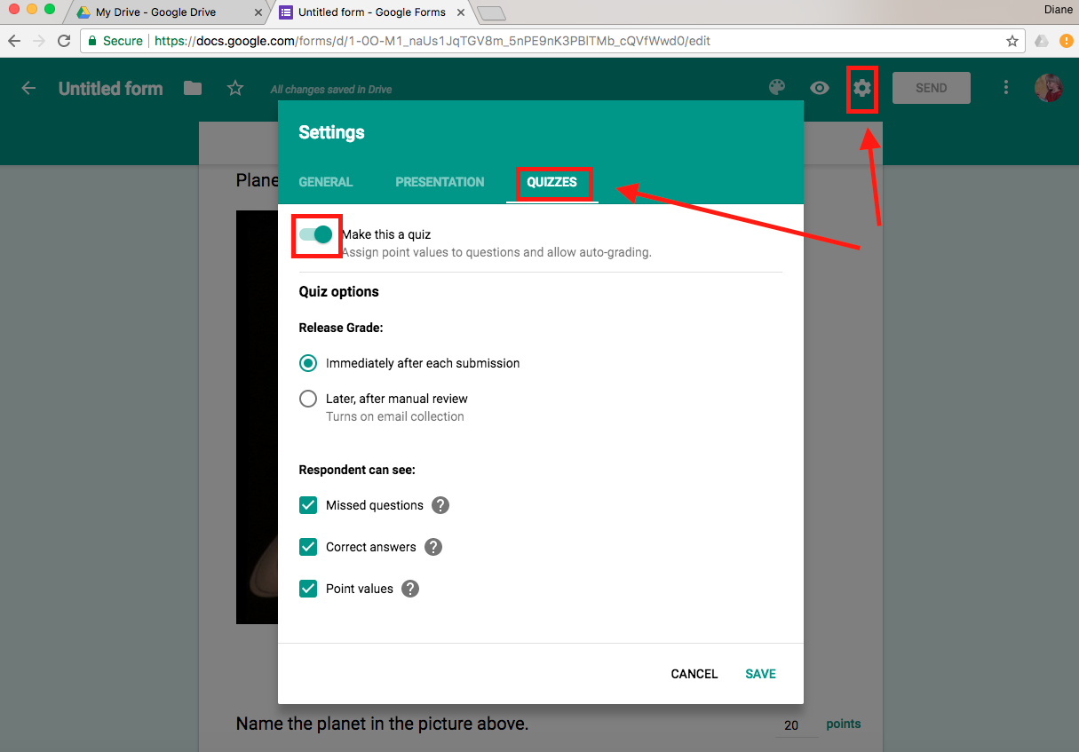

Change Header Format Directions
- Color
  - Select Color pallet > select desired color
- Add image
  - Select Color pallet > select image > choose from available themes or choose your own photo from Upload Photos or Your Albums icons.

Share A Google Form
- Share as email: Select Send.
- In the popup, type in email address.
- Check “include form in email”.
- Share as a URL: Select Send.
- In the popup, select Link button.
- Copy the link and paste the link into an email.
- In the Invite People text field, type in desired emails or names of collaborators.
- Select Done button.
- There are options to enable collaborators to edit and to allow collaborators to invite additional collaborators.
Note: Currently, the Google form created on a computer and emailed to an iPad did not go appear in my iPad’s email inbox. However, I could email the form’s URL link and was successful opening the form on the iPad.

Responses
As students answer the questions, you can view the responses in ‘real time’ as they come in or view all the responses at a later time.
- Select Responses button at the top of the page. The number beside the Responses tab indicates how many students have submitted their Google Form.
- There are three viewing options: Summary, Question, and Individual.
- To stop accepting responses (students cannot submit late assignments), toggle Accepting Responses on/off.

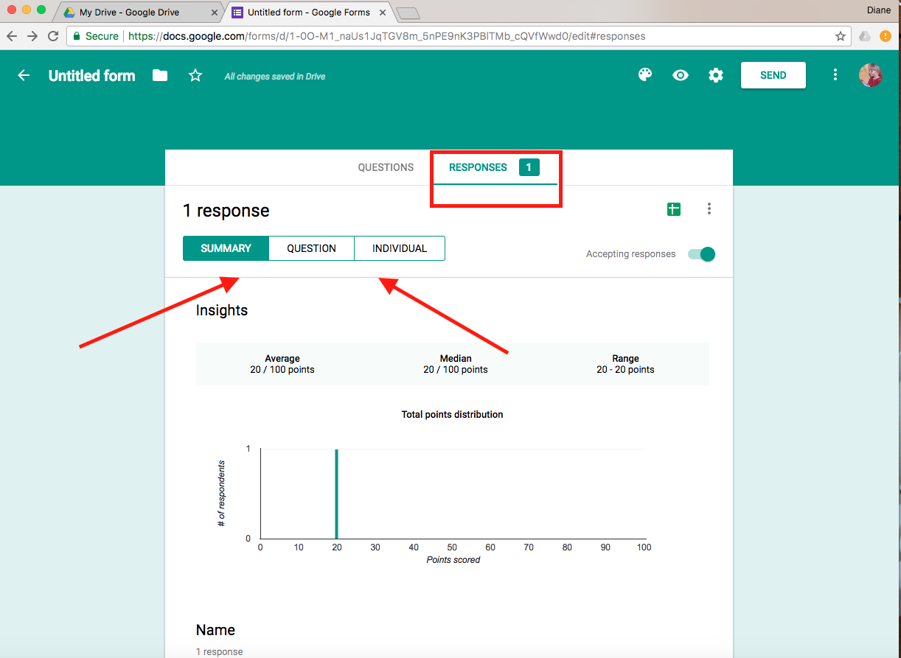

Google Form Collaboration (with other teachers)
- When emailing the Google Form, select the add collaborators link.
- Type in email address.
- Select Done button.
Or
- Select More button (three vertical dots in top right corner)
- Select Add Collaborators.
- Type in email address.
- Select Done button.

Google Form on iPad
You cannot access Google Forms by going through Google Drive; and, there is NOT a Google Form app! You must go through a web browser!
- Open Safari
- Drive.google.com
- Sign in
- Click on three horizontal bars (to left of My Drive)
- Select Desktop version
- Select New button (Located on the left; button has a blue background)
- In the dropdown menu, select More > Google Forms

Follow instructions above (Google Forms Directions – Computer) to create content in Google Forms.
Note: Currently, when using VoiceOver on the iPad, you cannot select the video to play the video. (Often, the video will crash Google Forms.) The videos work correctly on the iPad without VoiceOver.

Teacher Hint: On-line assessments have multiple types of questions. Your students – especially those using a screen reader - need to be familiar with these various question types and comfortable navigating and answering these questions! It is important to regularly provide homework assignments, quizzes and tests in similar formats!

